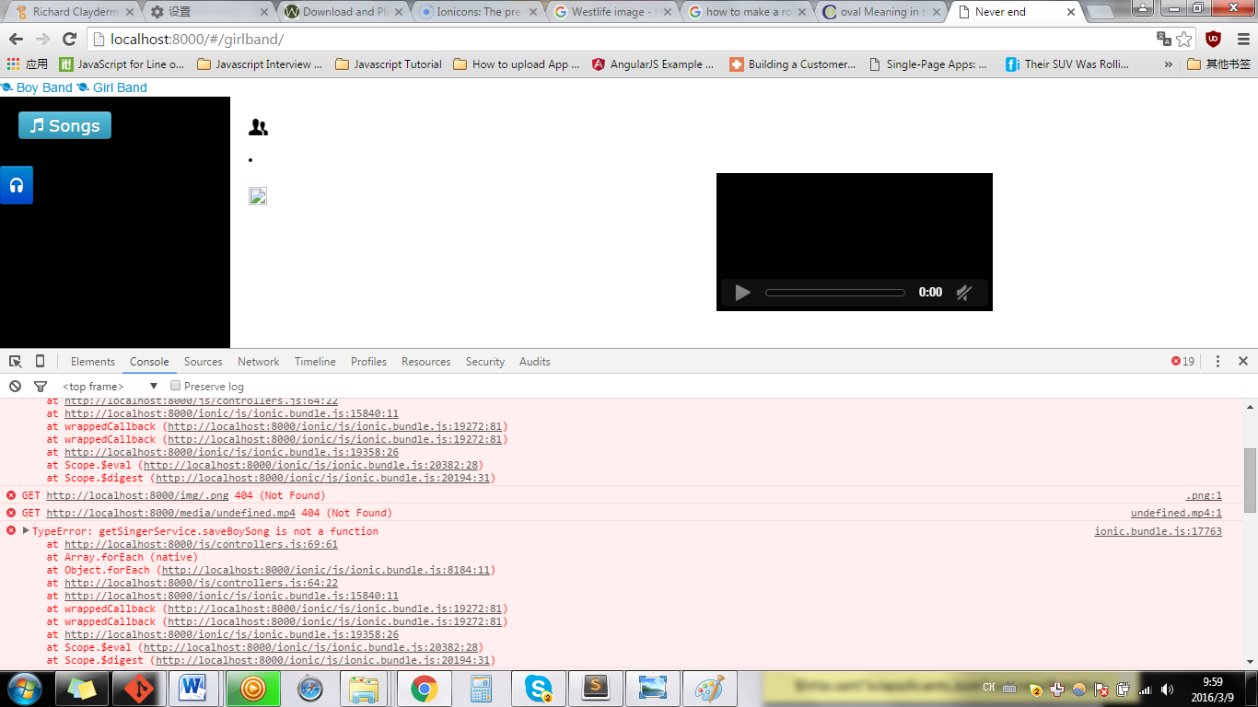

Localhost:……………\*\*\*\*\*\*\*\*\*\*\*\*\*\*404 not found

\*\*\*\*\*\*\*\*\*\*\*\***\*CHECK WITH THE DATA SOURCES, SUCH AS :SERVICES OR JSON FILES….**